# Thiio CRUD

This web application allows you to manage user accounts in a simple yet robust manner. It includes functionalities for user registration, login, viewing, editing, and deleting user profiles.

**Requirements**

* PHP (versión 8.0.26)
* Laravel (versión 8.83.27)
* MySQL (versión 8.0.31)
* Node.js (versión v18.17.1)
* Vue.js (versión 5.0.8)
* Phpunit (9.6)
* Vuetify (3.6.0)

**Installation**

**Database**

1. Create a database in MySQL named master and master_test directly from your MySQL client or from a tool like phpMyAdmin.
2. Import the master.sql and master_test.sql files located in the project's database folder.
3. Alternatively, you can run migrations from the command line at the project's root with the php artisan migrate command.

**Development Environment Configuration**

**Apache Virtual Host Configuration**

To facilitate development and ensure the application works correctly in your local environment, we've created a specific virtual host configuration. This configuration includes a local environment variable INSTALL_DIR that must be defined on your system.

Add the following configuration to your virtual hosts file (e.g., httpd-vhosts.conf or 000-default.conf). Make sure Apache can correctly resolve the INSTALL_DIR variable.

**In Wamp64**

• C:\wamp64\bin\apache\apache2.4.54.2\conf\extra\httpd-vhosts

**Add to the file:**

You'll find an httpd-vhosts file in the folder with the code.

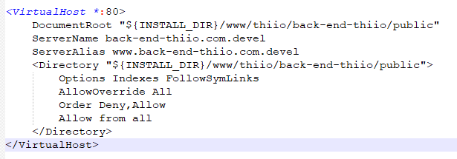

**Modify the Hosts File**

Add the following line to your hosts file to resolve the local domain:

• C:\Windows\System32\drivers\etc\hosts

127.0.0.1 back-end-thiio.com.devel

**Restart Apache**

After making these changes, restart Apache to apply the new configuration.

Once configured, you can access the application via the URL <http://back-end-thiio.com.devel>.

**Back-end**

1. Clone the Repository: Clone the repository containing both the backend and frontend code to your local machine with git clone <repository_url>.
2. Navigate to the Backend Directory: Go to the directory containing the backend code cd C:\wamp64\www\thiio\back-end-thiio.
3. Install Composer Dependencies: Run the following command to install Composer dependencies for the backend composer install.
4. Configure Environment Variables in the .env file according to your credentials.  
   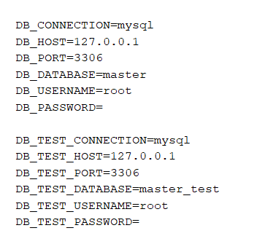
5. Generate Application Key by running php artisan key:generate.Run Migrations: If necessary, run migrations to create database tables php artisan migrate (if they were created manually, skip this step).
6. Start the Local Server with php artisan serve or directly from the local development environment.

**Front-end**

1. Navigate to the frontend folder C:\wamp64\www\thiio\frontend-thiio in the project.
2. Install Node.js dependencies by running npm install.
3. Run the development server with npm run serve.

**Note:** If you encounter issues with the Development Environment Configuration step, edit the file path in frontend-thiio\src\services\global.js to the address assigned to you by default (<http://localhost:8000>) or the one you prefer to use.

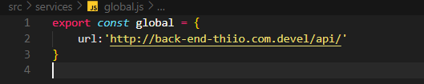

**Usage**

This project allows for the administration of user accounts through a simple yet robust web interface. Below are the steps to use the software from both an administrator's and an end user's perspective.

**Key Features**

1. User Registration
2. Login
3. Profile Viewing
4. Profile Editing
5. User Deletion